SPACERENTALS
A Long-Term Residential Rental Platform for Cameroon's Urban Rental Market
LIST OF FIGURES AND TABLES
Figures
Figure | Title | Section
3.1 | DSRM Process Model Applied to This Study | 3.2
3.2 | Agile / Scrum Iterative Development Cycle | 3.3
3.3 | Triangulation of Data Collection Methods | 3.4
3.4 | Use Case Diagram (Tenant, Landlord, Admin) | 3.7
3.5 | Activity Diagram: Rental Application to Lease Activation | 3.7
3.6 | UML Class Diagram of the Core Domain Model | 3.7
3.7 | Sequence Diagram: Digital Lease Signing & First Payment | 3.7
3.8 | Entity-Relationship Diagram of the Data Model | 3.7
3.9 | Three-Tier System Architecture | 3.8
3.10 | Application Workflow with Admin Oversight | 3.9

Tables
Table | Title | Section
3.1 | Mapping of DSRM Activities to This Project | 3.2
3.2 | Comparison of Agile and Waterfall Methodologies | 3.3
3.3 | Summary of Data Collection Methods | 3.4
3.4 | Functional Requirements of SpaceRentals | 3.6
3.5 | Non-Functional Requirements of SpaceRentals | 3.6
3.6 | UML and Data Modeling Diagrams Used in This Project | 3.7
3.7 | Technology Stack Summary by Architectural Layer | 3.10
3.8 | System Testing Strategy Summary | 3.11

CHAPTER ONE

INTRODUCTION

1.1 Background of the Study
Cameroon is urbanizing rapidly, with the national urbanization rate reaching 56.5% in 2023 and the residential real estate sector projected to grow at roughly 5% annually between 2025 and 2029 (Diamond Realty, 2021; The Africanvestor, 2026a). Douala and Yaoundé alone accounted for approximately 65% of all real estate transactions recorded nationally in 2024 (The Africanvestor, 2026a). This growth, however, is occurring against a severe and long-documented housing shortage: the national housing deficit is estimated at more than 2.5 million units (The Africanvestor, 2026a), and earlier academic studies of Douala and Yaoundé found that close to half of residents in those two cities live in informal settlements ("Identification, Analysis, Evaluation," 2015), a pattern more recent market analysis confirms still affects over 60% of urban dwellers today (SimTrade Blog, 2025).
Rental prices reflect this imbalance. Industry estimates place the average monthly rent for a one-bedroom apartment in central Douala or Yaoundé at roughly 456,000 XAF, compared to about 288,000 XAF outside the city centre, while a standard three-bedroom house in either city has been benchmarked at closer to 125,000 XAF per month (The Africanvestor, 2026b). Premium neighbourhoods such as Bastos in Yaoundé and Bonapriso and Bonamoussadi in Douala consistently command the highest rents, driven by security, infrastructure, and reliable utilities (The Africanvestor, 2026b). Despite this scale of activity, the process by which tenants find housing and landlords manage it remains almost entirely manual and informal: word-of-mouth referrals, unverified classifieds, paper agreements, and cash-in-hand rent payments.
At the same time, two enabling conditions make a digital solution to this problem realistic today. First, electronic signatures have carried formal legal recognition in Cameroon since 2010, through the OHADA Uniform Act on General Commercial Law together with the national Law on Electronic Commerce and the Law on Cybersecurity and Cybercriminality, all of which confirm that a contract cannot be denied enforceability solely because it was concluded electronically (Signable, 2024; DocuSign, n.d.). Second, mobile money is already the dominant channel for everyday payments in the country: MTN Mobile Money and Orange Money are the two leading providers nationally, and regional central bank data attributes the majority of mobile money transaction volume in the CEMAC zone to Cameroon alone (Business in Cameroon, 2025). Globally, the sector built around these enabling conditions, PropTech, was valued at approximately 45 to 47 billion US dollars in 2025 and is forecast to grow at a compound annual rate of roughly 13% to 16% through the early 2030s, with the residential segment and cloud-based software delivery models leading that growth (Precedence Research, 2026).
It is against this backdrop, rapid urban housing demand, a large informal and undocumented rental sector, and now both the legal and payment infrastructure required to digitize it, that this project proposes SpaceRentals, a long-term residential rental platform for the Cameroonian market.

1.2 Statement of the Problem
Long-term rental transactions in Cameroon's major cities are still conducted almost entirely offline. Tenants typically discover available units through informal word-of-mouth networks, unverified social-media posts, or general classifieds sites that were not purpose-built for rentals, and they have no reliable way to confirm that a listing, its price, or its landlord is genuine before travelling to view it in person. Landlords, in turn, have no structured way to receive, compare, or screen applications, and commonly fall back on manual paper agreements that offer little protection if a dispute arises later. Rent is collected largely in cash or through informal mobile money transfers with no automatic record-keeping, which makes it difficult for a landlord to track who has paid, who is overdue, and by how much, across multiple units or tenants.
The closest available digital tools only address part of this problem. General classifieds platforms and dedicated Cameroonian property-listing applications, reviewed in detail in Chapter Two, allow a landlord to publish a listing and be contacted by an interested party, but none of them carry the transaction through application review, tenant screening, digital lease signing, recurring rent invoicing, or maintenance tracking. As a result, even a tenant and landlord who successfully connect online must still fall back on manual, offline processes for every subsequent step of the rental relationship. There is currently no single Cameroonian platform that manages the complete long-term rental lifecycle, from discovery through lease signing, payment, and maintenance, in one connected system. This project addresses that specific gap.

1.3 Objectives of the Study
1.3.1 General Objective
The general objective of this project is to design and develop SpaceRentals, a web-based long-term rental platform that connects tenants and landlords directly, with administrative oversight, to digitize the full residential rental lifecycle in Cameroon's urban rental market.
1.3.2 Specific Objectives
- To design a searchable property listing and discovery module that allows tenants to filter long-term rental units by location, price, and property attributes.
- To design a rental application workflow that allows tenants to submit supporting documents and allows landlords to review, approve, or reject applications from a single dashboard.
- To implement a digital lease-signing workflow that is consistent with Cameroon's legal recognition of electronic signatures under the OHADA Uniform Act and national e-commerce law.
- To implement a recurring rent invoicing and collection module integrated with MTN Mobile Money and Orange Money, the two dominant mobile payment providers in Cameroon.
- To design a maintenance request and tracking module that allows tenants to report issues and landlords to monitor resolution status.
- To design an administrative dashboard that gives platform administrators oversight of accounts, listings, transactions, and disputes for compliance and reporting purposes.

1.4 Research Questions
- How can a searchable listing and discovery module be designed to help tenants in Cameroon's urban centres locate verified long-term rental units efficiently?
- What application and screening workflow best allows landlords to review and decide on tenant applications without third-party agents?
- How can a digital lease-signing workflow be implemented so that it is legally enforceable under Cameroon's existing e-commerce and electronic signature framework?
- How can recurring rent collection be automated using the mobile money channels that Cameroonian tenants and landlords already use?
- What system design allows administrators to maintain oversight, resolve disputes, and generate compliance reports across the platform?

1.5 Significance of the Study
For tenants, the platform removes the uncertainty of unverified listings and gives them a documented, traceable record of their applications, lease, and payment history. For landlords, it removes reliance on manual paperwork and agent commissions, and gives them a single dashboard to track applications, rent, and maintenance across every unit they own. For platform administrators and, by extension, the wider rental market, it introduces a layer of oversight, dispute resolution, and reporting that is largely absent from the current informal market. Academically, the project contributes a documented case study of applying long-term-rental-specific system design to an African urban market shaped by high mobile money penetration and a distinct legal framework for electronic contracts, extending existing PropTech literature, which is overwhelmingly focused on North American and European markets, into a West and Central African context.

1.6 Scope and Delimitation of the Study
The system is a residential rental marketplace and management platform built exclusively for long-term rentals. It does not support short-term stays, vacation bookings, or nightly and weekly rentals, which distinguishes it from short-term-rental-oriented platforms such as Airbnb-style booking engines. Within scope are property and unit listings, tenant onboarding and screening, rental applications, digital lease workflows, recurring rent invoicing and collection, maintenance request handling, in-app messaging and notifications, and administrative reporting.
Compared to a typical three-sided rental marketplace, SpaceRentals deliberately removes the Agent role. Landlords are responsible for creating and managing their own listings, reviewing and approving applications, generating leases, and tracking rent and maintenance directly. This simplifies the permission model and reduces the system to two customer-facing roles, Tenant and Landlord, plus one operational role, Admin, which lowers onboarding friction for individual landlords who are common in the target market and reduces the platform's operating overhead.
The project is delimited to the design, development, and evaluation of the platform's core modules as a proof-of-concept system, with primary reference to the Yaoundé and Douala rental markets. It does not extend to property sales or purchase transactions, commercial or short-term leasing, construction or land-titling processes, or full integration with formal banking or credit-scoring institutions, all of which fall outside the defined scope of this study.

1.7 Definition of Terms
- Tenant: An end user seeking to rent a residential unit through the platform.
- Landlord: A property owner who lists and manages one or more rental units on the platform.
- Admin: An internal platform operator responsible for oversight, moderation, and compliance.
- OHADA: Organisation pour l'Harmonisation en Afrique du Droit des Affaires, the regional business-law framework that governs electronic contracts in Cameroon.
- MoMo: MTN Mobile Money, a leading mobile payment service used for rent collection.
- XAF: Central African CFA franc, the currency used for all monetary values on this platform.
- PropTech: Property Technology, the sector of software and digital tools applied to real estate processes.
- TAM: Technology Acceptance Model, the theoretical framework used in Chapter Two to explain user adoption of the platform.
- DSRM: Design Science Research Methodology, the research paradigm used in Chapter Three to structure the development and evaluation of the platform.

1.8 Organization of the Study
This project is organized into six chapters. Chapter One has introduced the background, problem statement, objectives, research questions, significance, and scope of the study. Chapter Two reviews conceptual literature, the theoretical framework, and existing rental and property-management platforms, both international and Cameroonian, in order to situate SpaceRentals relative to prior work and identify the specific gap it addresses. Chapter Three presents the research methodology and system development approach. Chapter Four covers system analysis and design, including the data model and architecture. Chapter Five documents implementation and testing. Chapter Six presents the summary, conclusion, and recommendations for future work.

CHAPTER TWO

LITERATURE REVIEW

2.1 Introduction
This chapter reviews literature relevant to the design of SpaceRentals under four headings. Section 2.2 defines the core concepts underpinning digital rental platforms. Section 2.3 presents the theoretical framework used to explain user adoption. Section 2.4 reviews existing rental and property-management platforms, both international benchmarks and systems already operating in Cameroon and the wider African market. Section 2.5 reviews the legal and regulatory context governing electronic contracts and payments in Cameroon. Section 2.6 synthesizes this review into the specific gap that this project addresses.

2.2 Conceptual Review
PropTech. Property Technology, commonly abbreviated PropTech, refers to the application of digital technology to real estate processes, including listing, transacting, financing, and managing property. The global PropTech market was valued at approximately 45 to 47 billion US dollars in 2025 and is projected to grow at a compound annual rate of roughly 13% to 16% through the early 2030s, with residential applications and cloud-based, software-as-a-service delivery models accounting for the largest share of that market. The narrower category of rental property management software, which covers tenant and lease management, rent collection, and maintenance workflows, was itself estimated at 58.47 billion US dollars in 2025 with a forecast annual growth rate above 21% through 2035, reflecting how rapidly rental-specific digital tooling is being adopted worldwide.
Digital lease signing and electronic contracts. An electronic signature is a digital mechanism used to indicate a party's consent to a contract without a handwritten signature. Legal recognition of electronic signatures varies by jurisdiction, but a growing body of commercial law, including the OHADA framework applicable in Cameroon, treats electronically concluded contracts as enforceable provided the parties are competent to contract and their consent can be evidenced.
Mobile money. Mobile money refers to financial services, principally person-to-person transfers and merchant payments, conducted through a mobile phone account rather than a traditional bank account. In much of Sub-Saharan Africa, mobile money has become the primary channel for everyday payments in the absence of widespread formal banking penetration, a pattern strongly reflected in Cameroon, where MTN Mobile Money and Orange Money dominate the market.

2.3 Theoretical Framework: The Technology Acceptance Model
This project adopts the Technology Acceptance Model (TAM) as its guiding theoretical framework. TAM was developed by Fred Davis in the 1980s to predict how likely individuals are to adopt a new information system, and it remains one of the most widely applied models in information systems research. The model proposes that a user's intention to adopt a new system is shaped by two primary constructs: perceived usefulness, the degree to which a person believes the system will improve their performance of a task, and perceived ease of use, the degree to which they believe using the system will be free of effort. Together, these constructs shape the user's attitude toward the system, which in turn predicts actual adoption and use.
TAM is directly relevant to SpaceRentals because the platform's two customer-facing roles, tenants and landlords, are both being asked to replace a familiar, informal, offline process with a new digital one. For tenants, perceived usefulness depends on whether the platform genuinely surfaces verified, relevant listings faster than existing informal channels, while perceived ease of use depends on a simple, mobile-first interface suited to varying levels of digital literacy. For landlords, perceived usefulness depends on whether the platform measurably reduces the administrative burden of managing applications, rent, and maintenance, while perceived ease of use depends on the platform integrating with a payment method, mobile money, that they already use daily. These two constructs directly inform several of the non-functional and usability requirements defined later in this project's system design.

2.4 Review of Existing and Related Systems
2.4.1 International Benchmark Platforms
In mature rental markets, dedicated property management platforms such as AppFolio and Buildium provide an integrated view of the features SpaceRentals aims to bring to the Cameroonian market. Both platforms offer online rental applications and digital lease signing, online rent collection, tenant and owner portals, maintenance request tracking, and integrated accounting and reporting, with AppFolio additionally offering AI-assisted leasing tools and Buildium offering free listing syndication to networks such as Zillow Rental Network and Apartments.com. These platforms validate that an integrated, full-lifecycle rental system is both technically achievable and commercially viable, but they are priced, structured, and payment-integrated for a North American context: AppFolio requires a minimum of roughly 50 to 500 units and monthly fees starting near 298 US dollars, and neither platform integrates with mobile money, which makes them unsuitable, as configured, for individual landlords managing one or a handful of units in Cameroon.
2.4.2 Regional and Cameroonian Platforms
Within Cameroon and the wider African market, the closest existing systems are general classifieds and dedicated listing platforms rather than full rental-management systems. Jumia's real estate vertical is reported to be Cameroon's largest real estate listing site by traffic, but it functions as a general classifieds board rather than a rental-specific workflow tool. Ndabose is a dedicated Cameroonian real estate mobile application that allows users to search, filter, and favourite property listings for rent, sale, or shared occupancy across Cameroonian cities, while Afrirentals offers verified, bilingual property listings with direct contact between landlords and tenants and tools aimed at property owners and agents. Across the wider region, platforms such as Jiji operate as broad, multi-category classifieds sites where real estate is only one of many listing types, which reviewers note results in listings that frequently lack verified ownership, consistent detail, or specialized moderation.
What each of these Cameroonian and regional platforms has in common is that their functionality stops at discovery and initial contact. None of them provide a structured rental application and screening workflow, a digital lease-signing mechanism, automated recurring rent invoicing, or in-platform maintenance tracking; once a tenant and landlord connect through a listing, every subsequent step of the rental relationship still happens offline, through the same informal, undocumented channels this project's problem statement describes.

2.5 Legal and Regulatory Review
Cameroonian law does not require a handwritten signature for a contract to be valid; an agreement is binding once legally competent parties consent to it, whether verbally, on paper, or electronically. Electronic signatures have carried formal legal recognition in Cameroon since 2010, through the OHADA Uniform Act on General Commercial Law together with the national Law on Electronic Commerce (Law No. 2010/021) and the Law on Cybersecurity and Cybercriminality (Law No. 2010/012), both of which confirm that a contract cannot be denied enforceability solely because it was concluded electronically. The literature notes an important qualification, however: while such contracts are enforceable, parties may still need to produce supporting evidence of consent if a dispute is brought to court, which is why leading digital transaction platforms retain timestamped, auditable signature records rather than a bare electronic mark. This directly informs the audit-logging requirement carried into SpaceRentals's digital lease-signing module.
On the payment side, mobile money is not merely a convenience in Cameroon but the dominant channel for digital transactions generally. MTN Mobile Money and Orange Money are the two leading providers nationally, and regional central bank data attributes a majority of both mobile money transaction volume and value in the CEMAC zone to Cameroon alone. Any rent-collection module designed for this market must therefore treat mobile money integration as a functional requirement rather than an optional payment method, a conclusion the literature supports consistently across market and policy sources.

2.6 Summary of Literature Review and Identified Gap
The literature reviewed in this chapter establishes three things. First, Cameroon's rental market is large, growing, and structurally undersupplied, creating clear demand for a more efficient way to match tenants with housing. Second, mature international platforms such as AppFolio and Buildium demonstrate that an integrated, full-lifecycle rental management system is technically achievable, but none of these platforms are configured for individual landlords or mobile-money-based payment in a Cameroonian context. Third, the platforms that do operate in Cameroon today, including Jumia's real estate vertical, Ndabose, and Afrirentals, address only the discovery and initial-contact stage of the rental process, leaving application review, digital lease signing, recurring rent collection, and maintenance tracking entirely outside their scope.
The specific gap this project addresses, therefore, is the absence of a single Cameroonian platform that carries a long-term rental relationship through its complete lifecycle, from verified discovery through application, legally compliant digital lease signing, mobile-money-based recurring rent collection, and maintenance tracking, in one connected system built around the country's existing legal and payment infrastructure. SpaceRentals is designed to close that gap.

CHAPTER THREE

METHODOLOGY OF STUDY

3.1 Introduction
This chapter presents the methodology adopted to design, develop, and evaluate SpaceRentals. It covers the overarching research design, the system development methodology used to build the software artifact, the methods used to collect and validate data, the modeling tools used to specify the system, the system architecture and technology stack selected for implementation, the testing strategy, and the ethical considerations that guided the project. Diagrams and tables are used throughout to present the methodology in the visual form expected for a project defense, and each figure and table is numbered, captioned, and referenced directly from the surrounding text.

3.2 Research Design
This project follows a Design Science Research (DSR) approach, which is the research paradigm most appropriate for information systems work whose central contribution is a designed artifact intended to solve a defined organizational or societal problem, as opposed to a natural-science study that only observes and explains existing phenomena. Design science research is oriented toward developing practical solutions that can be used by professionals in the field of information systems engineering, and the artifacts it produces may take the form of constructs, models, methods, or full system instantiations.
Specifically, this study adopts the Design Science Research Methodology (DSRM) process model, which structures a DSR project into six nominal activities: problem identification and motivation, definition of the objectives of a solution, design and development, demonstration, evaluation, and communication. Figure 3.1 illustrates this process as applied to the present study, including the iterative feedback loop back into design and development when evaluation reveals an unmet objective.
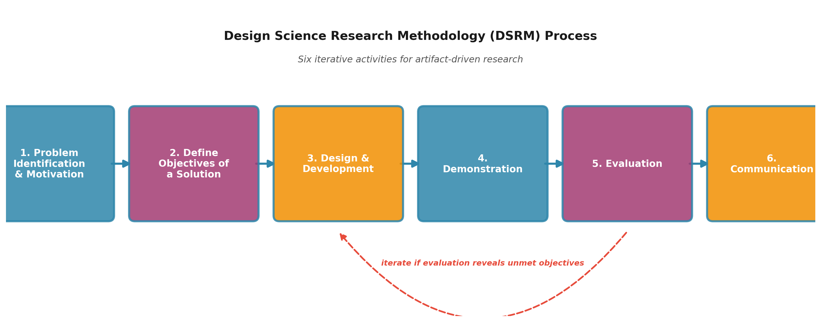
Figure 3.1: Design Science Research Methodology (DSRM) Process Model Applied to This Study
(Adapted from Peffers, Tuunanen, Rothenberger & Chatterjee, 2007)
Table 3.1 maps each of the six DSRM activities in Figure 3.1 onto the corresponding part of this project.
DSRM Activity | Description | Where Addressed in This Project
1. Problem identification  and motivation | Articulating the specific problem and why a solution has value | Chapter One, Sections 1.1-1.2
2. Define objectives  of a solution | Inferring the objectives of a solution from the problem definition | Chapter One, Section 1.3, refined by Chapter Two's gap analysis
3. Design and  development | Creating the artifact: architecture, data model, and functionality | Chapter Three, Sections 3.6-3.8; carried into Chapter Four
4. Demonstration | Using the artifact to solve representative instances of the problem | Role-based scenarios for Tenant, Landlord, and Admin (Section 3.4)
5. Evaluation | Observing and measuring how well the artifact supports a solution | Section 3.11, System Testing Strategy
6. Communication | Communicating the problem, artifact, and its utility to stakeholders | This dissertation and the project defense presentation
Table 3.1: Mapping of DSRM Activities to This Project
DSRM was preferred over a purely qualitative or purely quantitative empirical research design because the central deliverable of this project is a functioning software artifact, and DSRM is explicitly designed to keep artifact construction and its rigorous evaluation at the center of the research process, rather than treating the software as a secondary output of a survey or interview-based study.

3.3 System Development Methodology
SpaceRentals was developed using an Agile, iteration-based development methodology rather than a traditional Waterfall approach. Agile software development, formalized in the 2001 Manifesto for Agile Software Development, favors a responsive, collaborative process built around short, iterative development cycles rather than a single, rigidly sequenced set of phases. Within the Agile family, this project specifically follows Scrum-inspired practices: work is organized into a prioritized backlog of features, executed in time-boxed sprints of one to two weeks as shown in Figure 3.2, with each sprint producing a demonstrable increment of working software that is reviewed before the next sprint is planned.
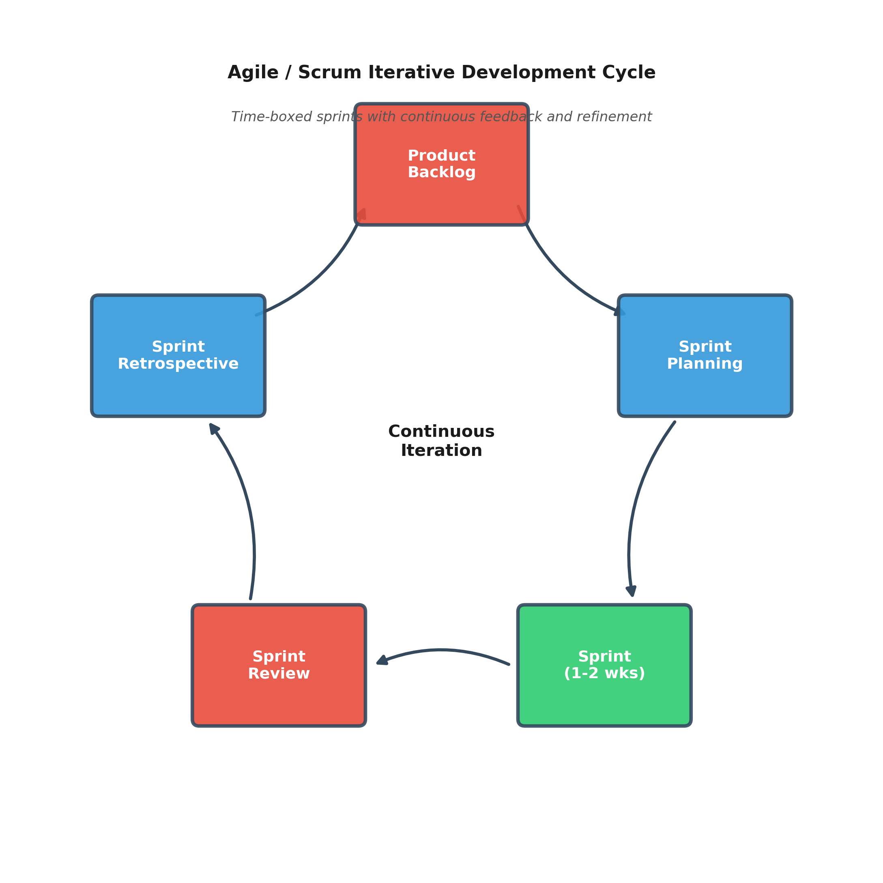
Figure 3.2: Agile / Scrum Iterative Development Cycle Used for SpaceRentals
This iterative approach was chosen over Waterfall for the reasons summarized in Table 3.2.
Criteria | Agile / Scrum (Adopted) | Waterfall (Not Adopted)
Requirements handling | Refined incrementally as each sprint reveals real constraints (e.g., mobile money integration) | Requires all requirements to be frozen before development begins
Delivery structure | Independent modules built, demonstrated, and refined in short cycles | Single sequential delivery at the end of a long development phase
Feedback and review | Supervisory and stakeholder feedback incorporated every sprint | Feedback typically only possible after a full phase is complete
Fit for an academic timeline | Short, reviewable increments align naturally with term-based milestones | Rigid phase gates fit poorly with a fixed academic calendar
Table 3.2: Comparison of Agile and Waterfall Methodologies for This Project

3.4 Data Collection Methods
Data for this project was collected through a triangulated combination of primary and secondary methods, illustrated in Figure 3.3, so that requirements derived from any single source could be cross-checked against the other two before being consolidated into the objectives defined in Chapter One.
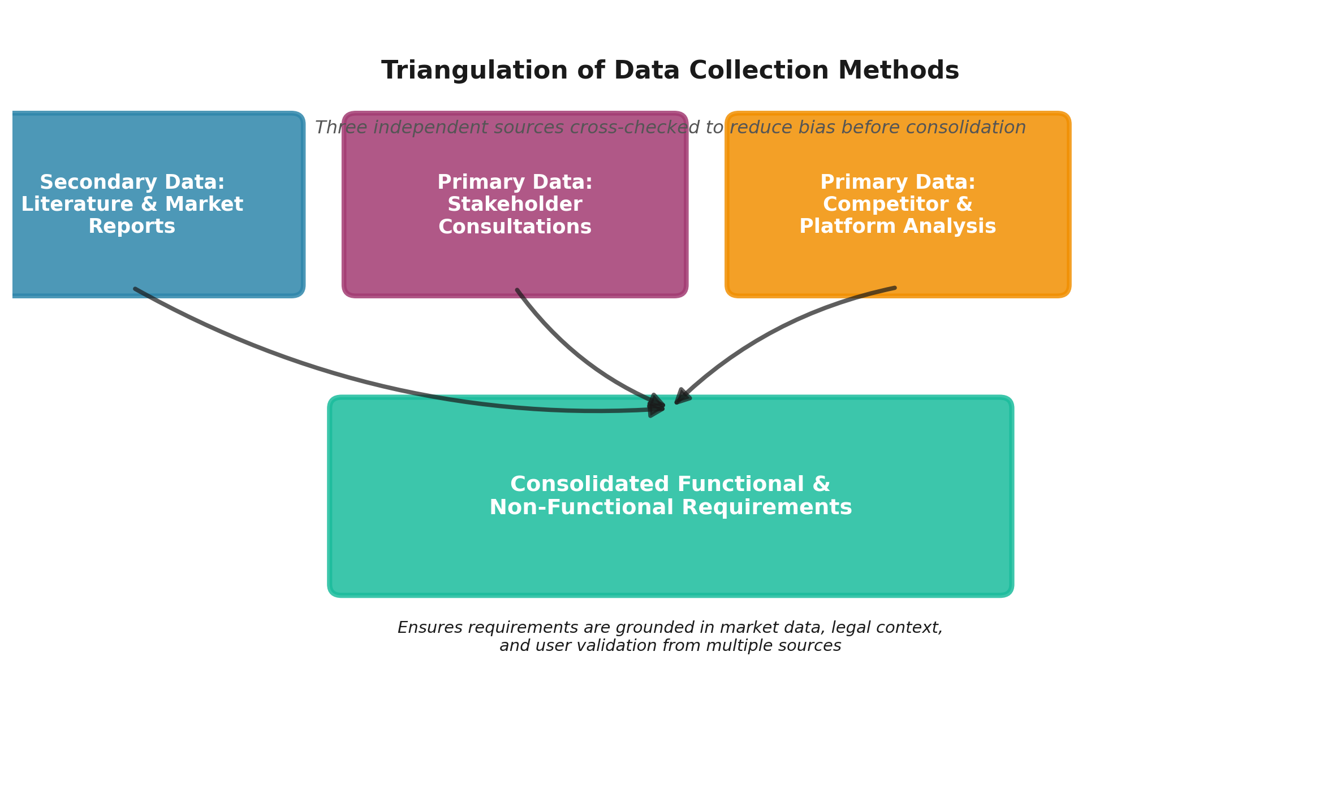
Figure 3.3: Triangulation of Data Collection Methods Used in This Study
Table 3.3 summarizes each data collection method, the type of data it produced, its source, the instrument used, and the purpose it served in shaping the system's requirements.
Method | Data Type | Source / Population | Instrument | Purpose
Literature and market review | Secondary | Published market reports, academic studies, legal texts (Chapter Two) | Structured desk review | Establish market size, legal context, and payment landscape
Stakeholder consultation | Primary, qualitative | Prospective tenants and landlords in Yaoundé (convenience sample) | Informal semi-structured discussion | Surface real pain points with cash rent and paper leases
Competitor / platform analysis | Primary, qualitative | Existing platforms: Jumia real estate, Ndabose, Afrirentals, AppFolio, Buildium | Feature-by-feature walkthrough and comparison | Identify functional gaps to design around (Chapter Two, 2.4)
Legal and regulatory review | Secondary | OHADA Uniform Act, national e-commerce and cybersecurity laws | Document analysis | Determine mandatory constraints on the lease-signing module
Table 3.3: Summary of Data Collection Methods
3.4.1 Primary Data Collection
Primary data was gathered directly by the researcher through two channels: informal stakeholder consultations with prospective tenants and landlords, and a structured, feature-by-feature comparison of existing rental and property-management platforms. Both were conducted specifically to fill gaps that the secondary literature could not address on its own, namely how Cameroonian tenants and landlords actually behave today and precisely which features competing platforms do and do not offer.
3.4.2 Secondary Data Collection
Secondary data was drawn from the published market, legal, and technology sources reviewed in Chapter Two, including national housing statistics, real estate market reports, mobile money adoption data, the text of Cameroon's OHADA-derived electronic commerce law, and PropTech industry market-sizing reports. These sources anchor the project's problem statement and objectives in independently verifiable figures rather than assumption.

3.5 Requirements Gathering Techniques
The requirements gathering process used the data collected in Section 3.4 in three stages: first, the literature and legal review in Chapter Two established non-negotiable constraints, most notably that the lease-signing module had to be compatible with OHADA's electronic signature framework and that the payment module had to integrate MTN Mobile Money and Orange Money. Second, competitor analysis established the specific functional gap, full-lifecycle rental management, that no existing Cameroonian platform closes. Third, stakeholder consultation validated that this gap reflects a genuine, felt pain point for prospective users rather than a purely theoretical one. These three inputs were consolidated into the general and specific objectives already presented in Chapter One, Section 1.3, and translated into the functional and non-functional requirements presented in Section 3.6.

3.6 Functional and Non-Functional Requirements
This section translates the objectives defined in Chapter One and the requirements gathering process described in Section 3.5 into the specific functional and non-functional requirements that guided the design and development of SpaceRentals. Functional requirements describe what the system must do; non-functional requirements describe the quality attributes the system must exhibit while doing it.
3.6.1 Functional Requirements
Table 3.4 lists the functional requirements grouped by the actor primarily responsible for triggering each one, consistent with the Tenant, Landlord, and Admin roles defined in Chapter One, Section 1.3, and the use case diagram in Figure 3.4.
ID | Requirement | Description | Actor
FR-01 | Account registration and role-based login | Users register and authenticate as a Tenant, Landlord, or Admin through Supabase Auth | All
FR-02 | Property listing management | Landlords create, edit, publish, and remove property listings | Landlord
FR-03 | Property search and filtering | Tenants search and filter available units by location, price, and property attributes | Tenant
FR-04 | Rental application submission | Tenants submit a rental application with supporting documents for a specific listing | Tenant
FR-05 | Application review and decision | Landlords review, approve, or reject submitted applications | Landlord
FR-06 | Digital lease generation and e-signature | The system generates a lease draft; Tenant and Landlord sign it electronically | Tenant, Landlord
FR-07 | Recurring rent invoicing and payment | The system issues rent invoices and accepts payment via MTN MoMo or Orange Money | Tenant
FR-08 | Payment history and receipts | Tenants and Landlords can view a traceable record of past rent payments | Tenant, Landlord
FR-09 | Maintenance request submission and tracking | Tenants submit maintenance requests; Landlords update and resolve their status | Tenant, Landlord
FR-10 | In-app and external notifications | The system notifies users of key events via in-app alerts, SMS, or email | All
FR-11 | User account moderation | Admins approve, suspend, or remove user accounts | Admin
FR-12 | Listing moderation | Admins review and moderate property listings for policy compliance | Admin
FR-13 | Transaction monitoring and audit logging | Admins monitor payment transactions and review timestamped audit logs | Admin
FR-14 | Dispute resolution management | Admins record, track, and resolve disputes raised by Tenants or Landlords | Admin
FR-15 | Platform reporting and analytics | Admins generate platform-wide reports on occupancy, revenue, and compliance | Admin
Table 3.4: Functional Requirements of SpaceRentals
3.6.2 Non-Functional Requirements
Table 3.5 lists the non-functional requirements, grouped by quality attribute, together with the justification or measurable target associated with each one. These requirements were derived directly from the market and legal context established in Chapter Two, particularly the need to support users on variable mobile network conditions and to satisfy Cameroon's electronic signature and data-protection expectations.
ID | Category | Requirement | Justification / Target
NFR-01 | Performance | Core screens (listing search, dashboard) should load within 3 seconds on a typical 3G/4G connection | Reflects variable mobile network conditions in the target market
NFR-02 | Security | All sensitive data is protected using role-based access control and Supabase Row-Level Security policies | Protects identity documents, lease data, and payment records (OWASP-aligned access control)
NFR-03 | Usability | Interfaces are mobile-first, simple, and legible to users with varying levels of digital literacy | Supports Technology Acceptance Model's perceived-ease-of-use construct (Chapter Two, Section 2.3)
NFR-04 | Reliability / Availability | The platform should maintain at least 99% uptime, excluding scheduled maintenance | Rent collection and lease access are time-sensitive for both Tenants and Landlords
NFR-05 | Scalability | The data and backend layer must scale to a growing number of listings and users without redesign | Supported natively by Supabase's managed, horizontally scalable infrastructure
NFR-06 | Compatibility / Portability | The client application must run consistently across Android, iOS, and modern web browsers | Delivered through a single React Native codebase
NFR-07 | Maintainability | Code is organized into modular, reusable components with version control | Reduces long-term maintenance cost and supports iterative Agile delivery (Section 3.3)
NFR-08 | Legal and regulatory compliance | The lease-signing workflow retains timestamped, auditable signature records | Required to satisfy Cameroon's OHADA-derived electronic signature framework (Chapter Two, Section 2.5)
Table 3.5: Non-Functional Requirements of SpaceRentals

3.7 System Analysis and Design Tools
System analysis and design for SpaceRentals are expressed using the Unified Modeling Language (UML), the standard visual modeling notation maintained by the Object Management Group (OMG) since UML 1.0 was first proposed in 1997, with the current UML 2.5 specification in effect since 2015. UML was selected because it is a general-purpose, process-independent notation that is equally legible to technical and non-technical stakeholders, which suits an academic project defense audience as well as the engineering team. Table 3.6 summarizes the specific diagram types used and where each is presented.
UML / Data Diagram | Purpose | Reference
Use Case Diagram | Captures functional interactions between the Tenant, Landlord, and Admin actors and the system | Figure 3.4
Activity Diagram | Captures the flow of control and decision points across actors for the rental application process | Figure 3.5
Class Diagram | Captures the static structure of core entities and their relationships | Figure 3.6
Sequence Diagram | Captures the time-ordered messages exchanged during the digital lease-signing and first-payment workflow | Figure 3.7
Entity-Relationship Diagram | Captures the relational data model and cardinalities used by the database layer | Figure 3.8
Table 3.6: UML and Data Modeling Diagrams Used in This Project
Figure 3.4 presents the use case diagram, showing how each actor's responsibilities, defined in Chapter One, Section 1.3, map onto discrete, testable system functions.
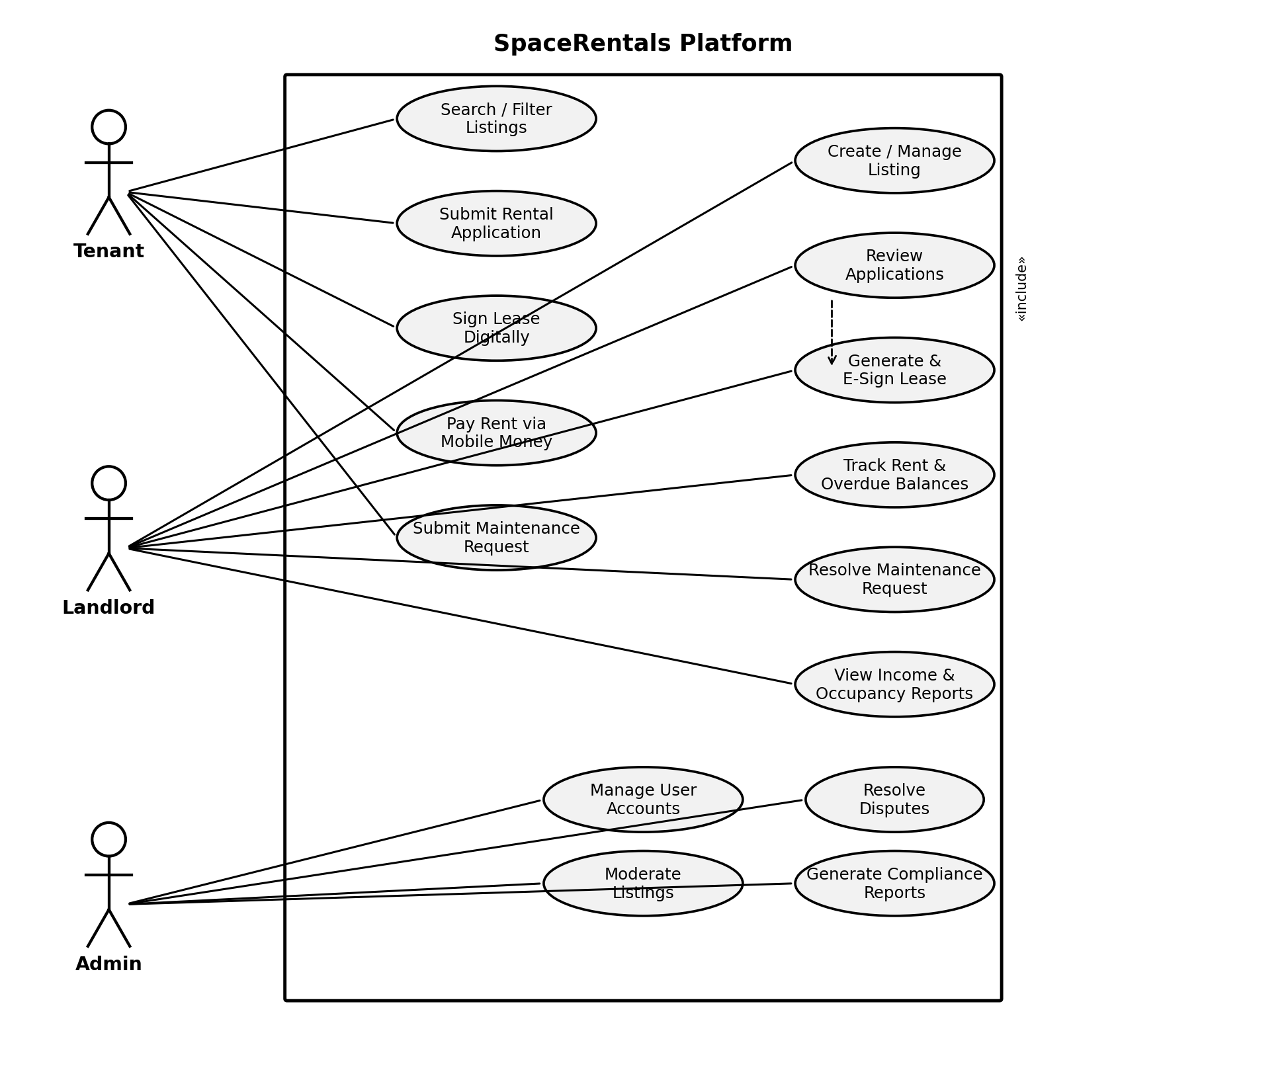
Figure 3.4: Use Case Diagram for the Tenant, Landlord, and Admin Actors
Figure 3.5 presents the activity diagram for the rental application process, the workflow that carries the platform's two customer-facing roles from initial listing search through to an active, signed lease. It is organized into three swimlanes, Tenant, SpaceRentals System, and Landlord, and includes the decision point at which a landlord either approves or rejects an application.
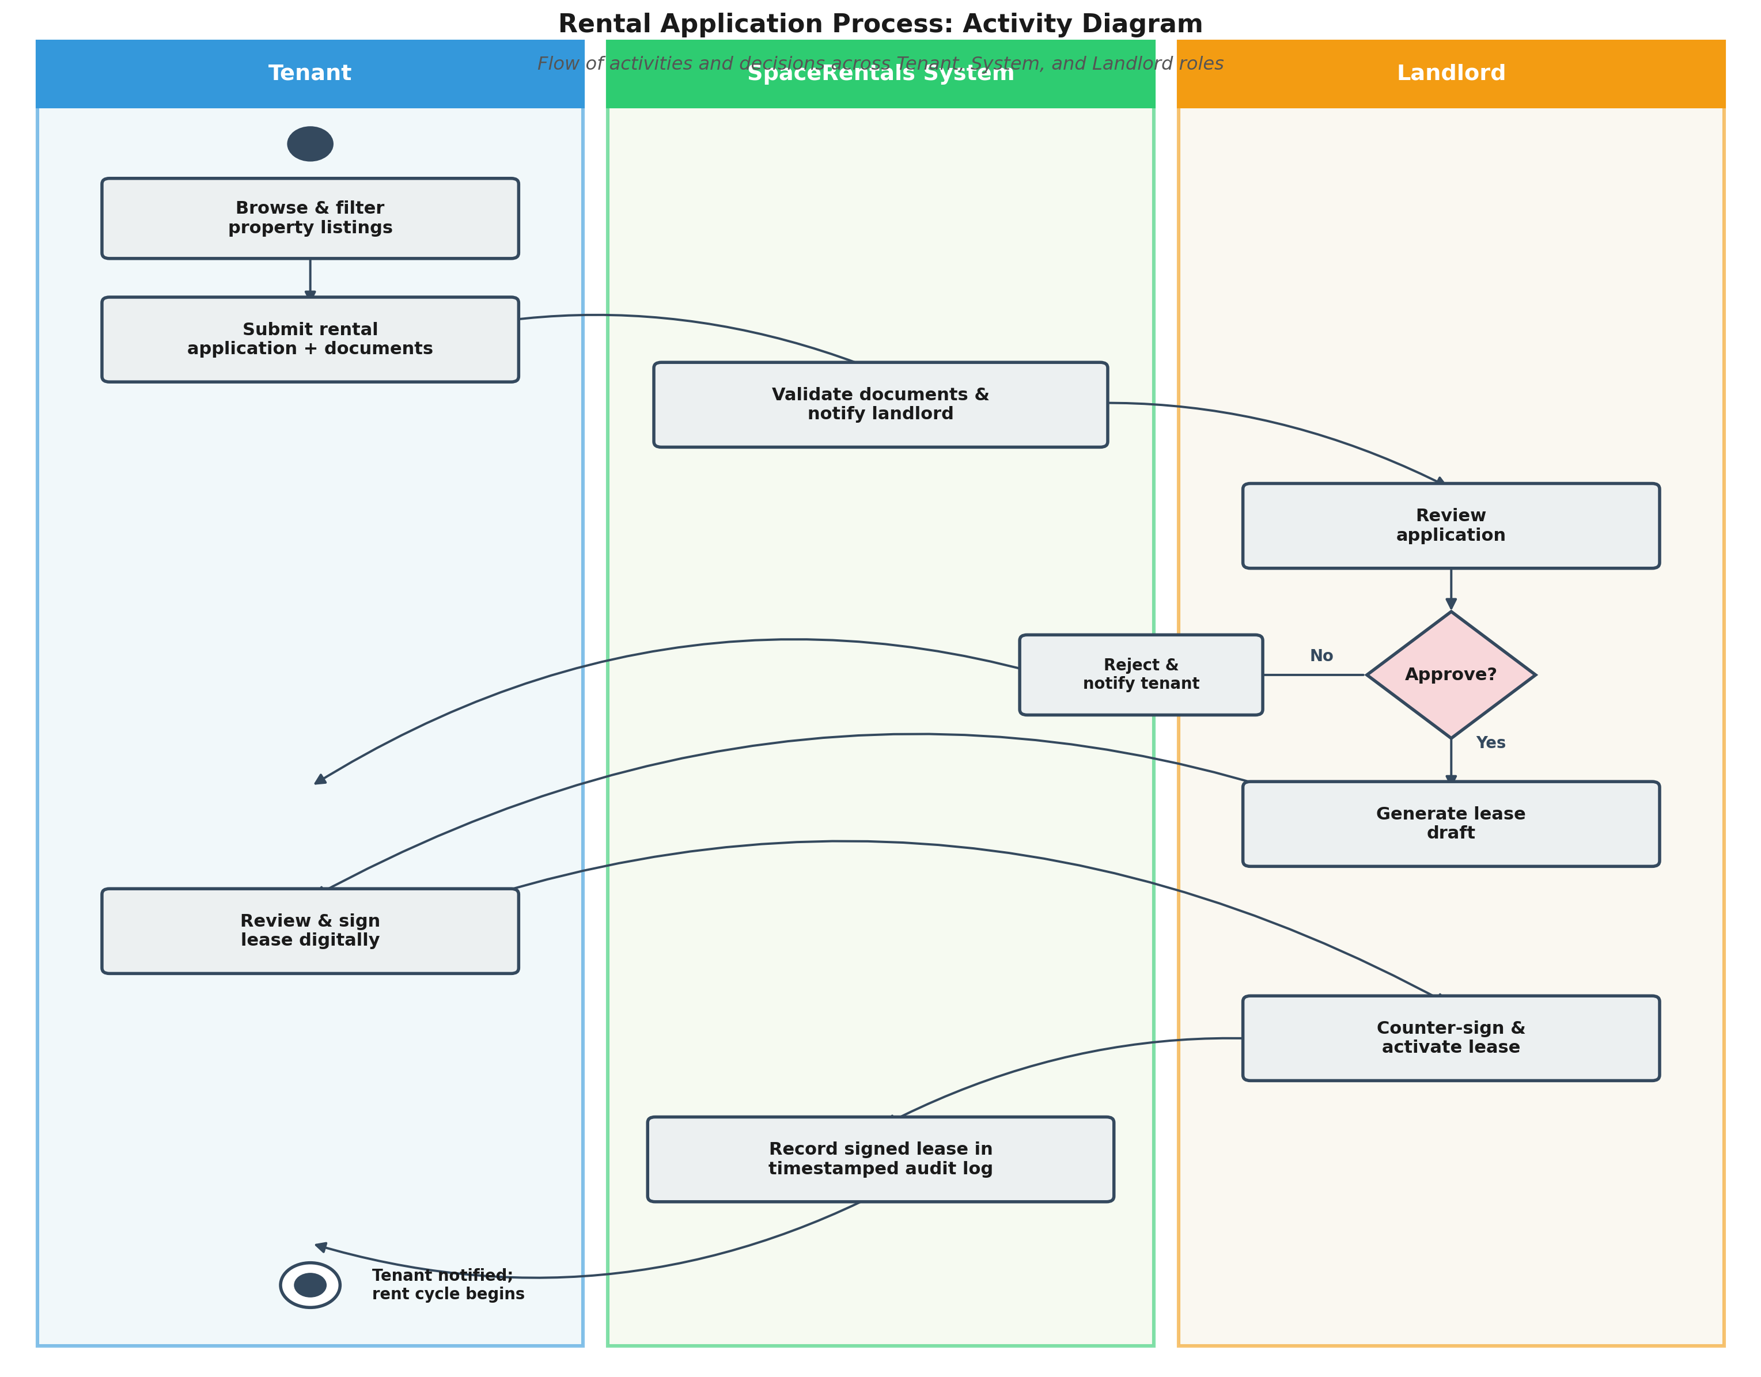
Figure 3.5: Activity Diagram for the Rental Application to Lease Activation Process
Figure 3.6 presents the class diagram covering the platform's core domain objects, User, Property, Application, Lease, Payment, MaintenanceRequest, and AuditLog, together with their key attributes, methods, and the relationships between them.
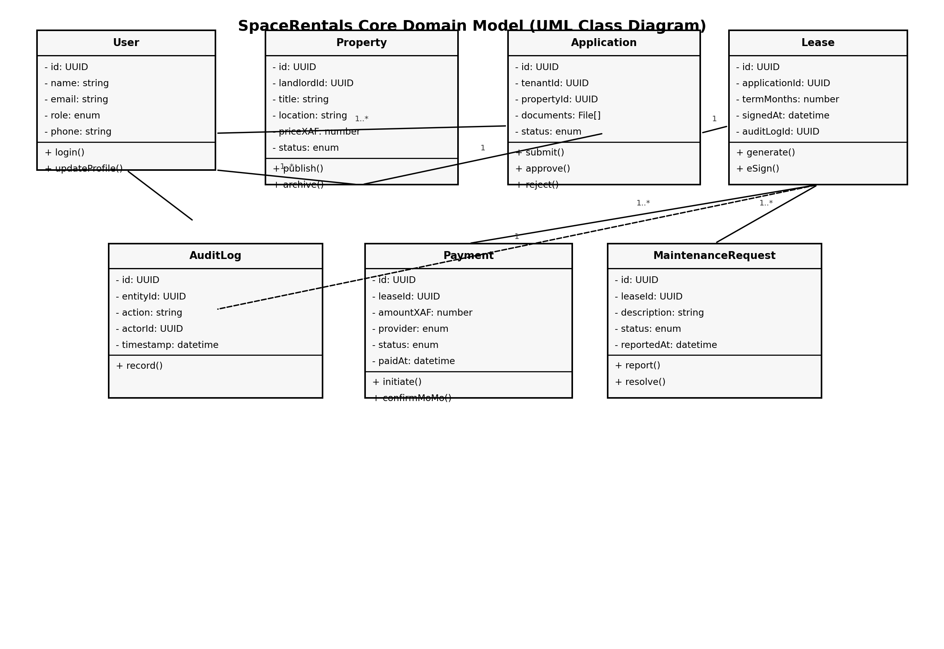
Figure 3.6: UML Class Diagram of the SpaceRentals Core Domain Model
Figure 3.7 presents the sequence diagram for the platform's most legally and financially sensitive workflow, digital lease signing followed by the first mobile-money rent payment, showing the ordered messages exchanged between the Tenant, the SpaceRentals system, the Landlord, and the external mobile money API.
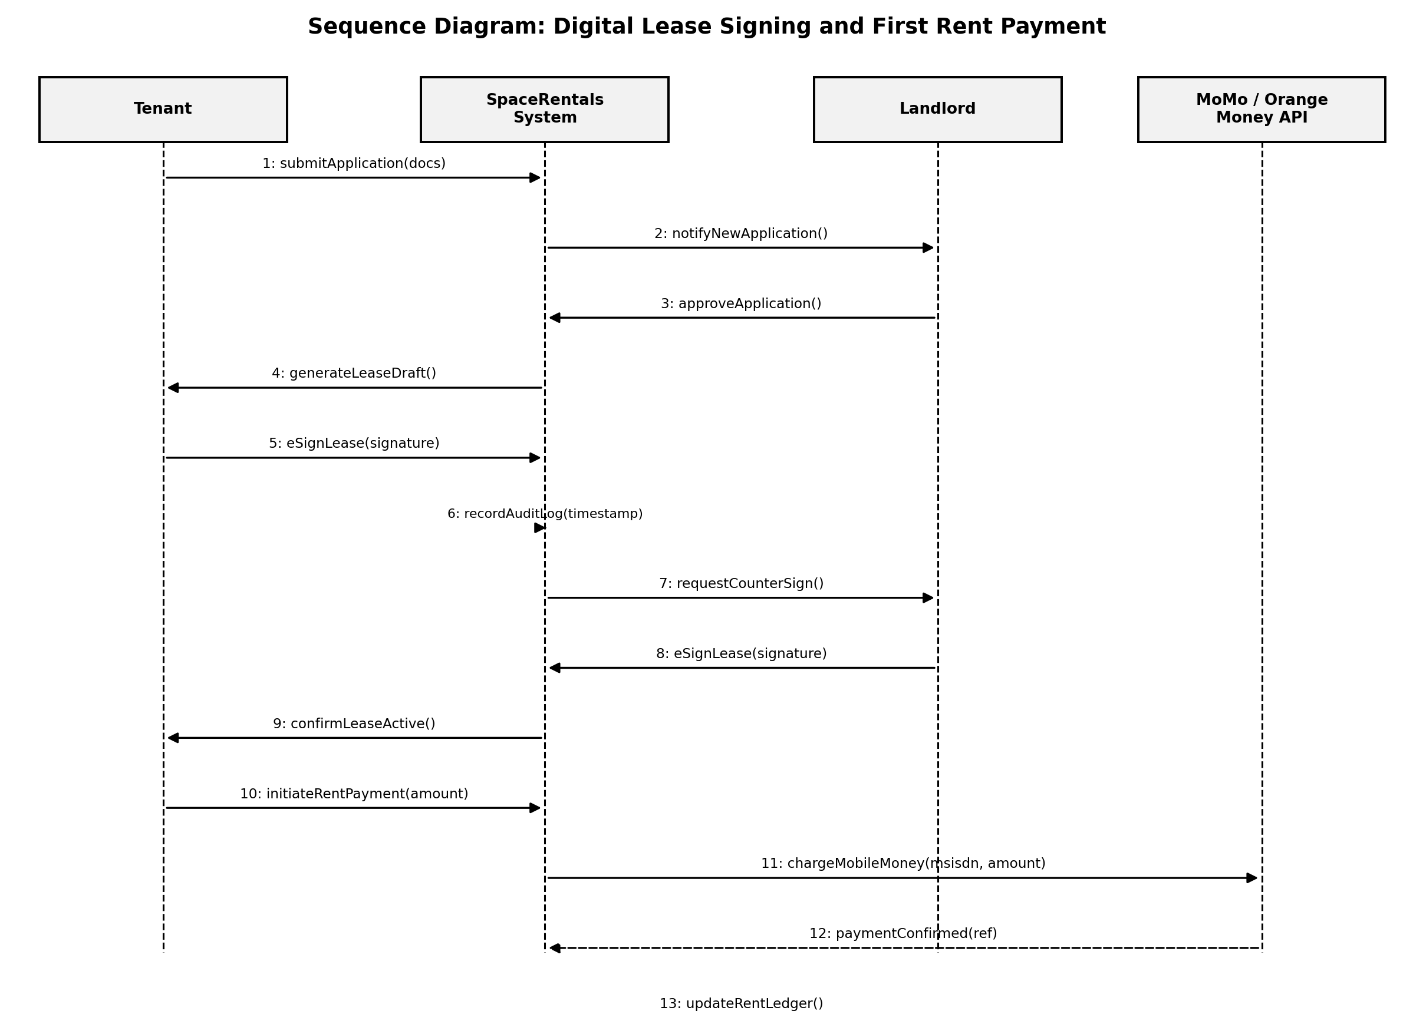
Figure 3.7: Sequence Diagram for Digital Lease Signing and First Rent Payment
Figure 3.8 presents the entity-relationship diagram underlying the class diagram in Figure 3.6, expressed in a simpler, database-oriented notation showing primary keys, foreign keys, and cardinalities.
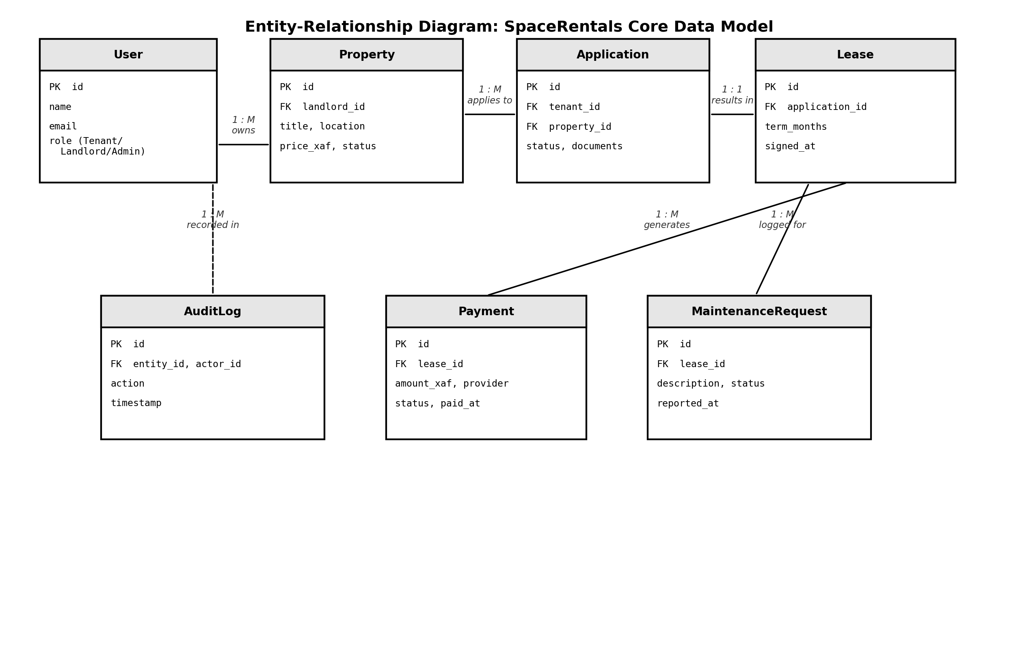
Figure 3.8: Entity-Relationship Diagram of the SpaceRentals Data Model

3.8 System Architecture
SpaceRentals follows a three-tier architecture, shown in Figure 3.9, which separates the client-facing presentation tier from a managed backend-as-a-service tier and its underlying data and storage tier, with a distinct external-services tier for the mobile money and notification providers that the platform depends on but does not control. Unlike a traditionally self-hosted backend, the application and data tiers are provided by Supabase as a single managed platform, which reduces the amount of backend infrastructure this project needs to build and maintain directly.
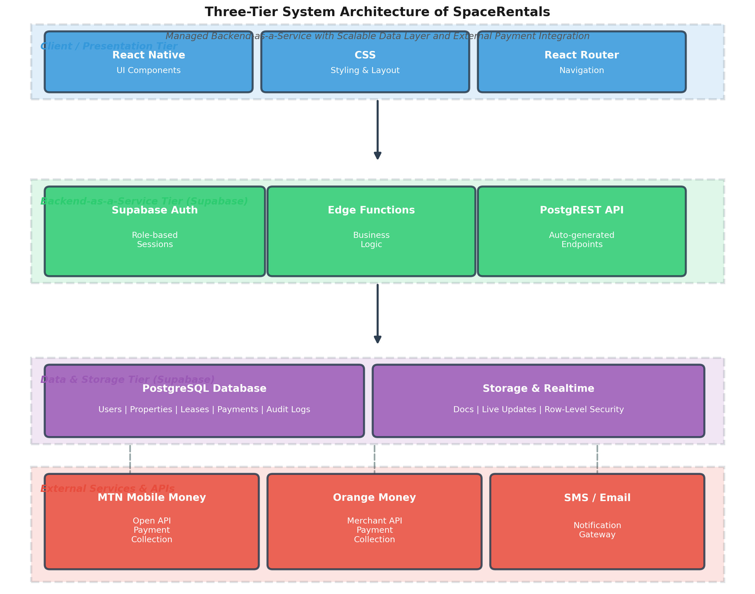
Figure 3.9: Three-Tier System Architecture of SpaceRentals

3.9 Application Workflow Overview
While Figure 3.5 details the activity-level logic of a single process, Figure 3.10 zooms out to show the complete SpaceRentals application workflow at the level a project defense panel typically expects to see first: the six sequential stages a tenant and landlord move through together, from account registration to maintenance close-out, with a continuous band of Admin oversight running underneath every stage rather than sitting only at the end of the process.
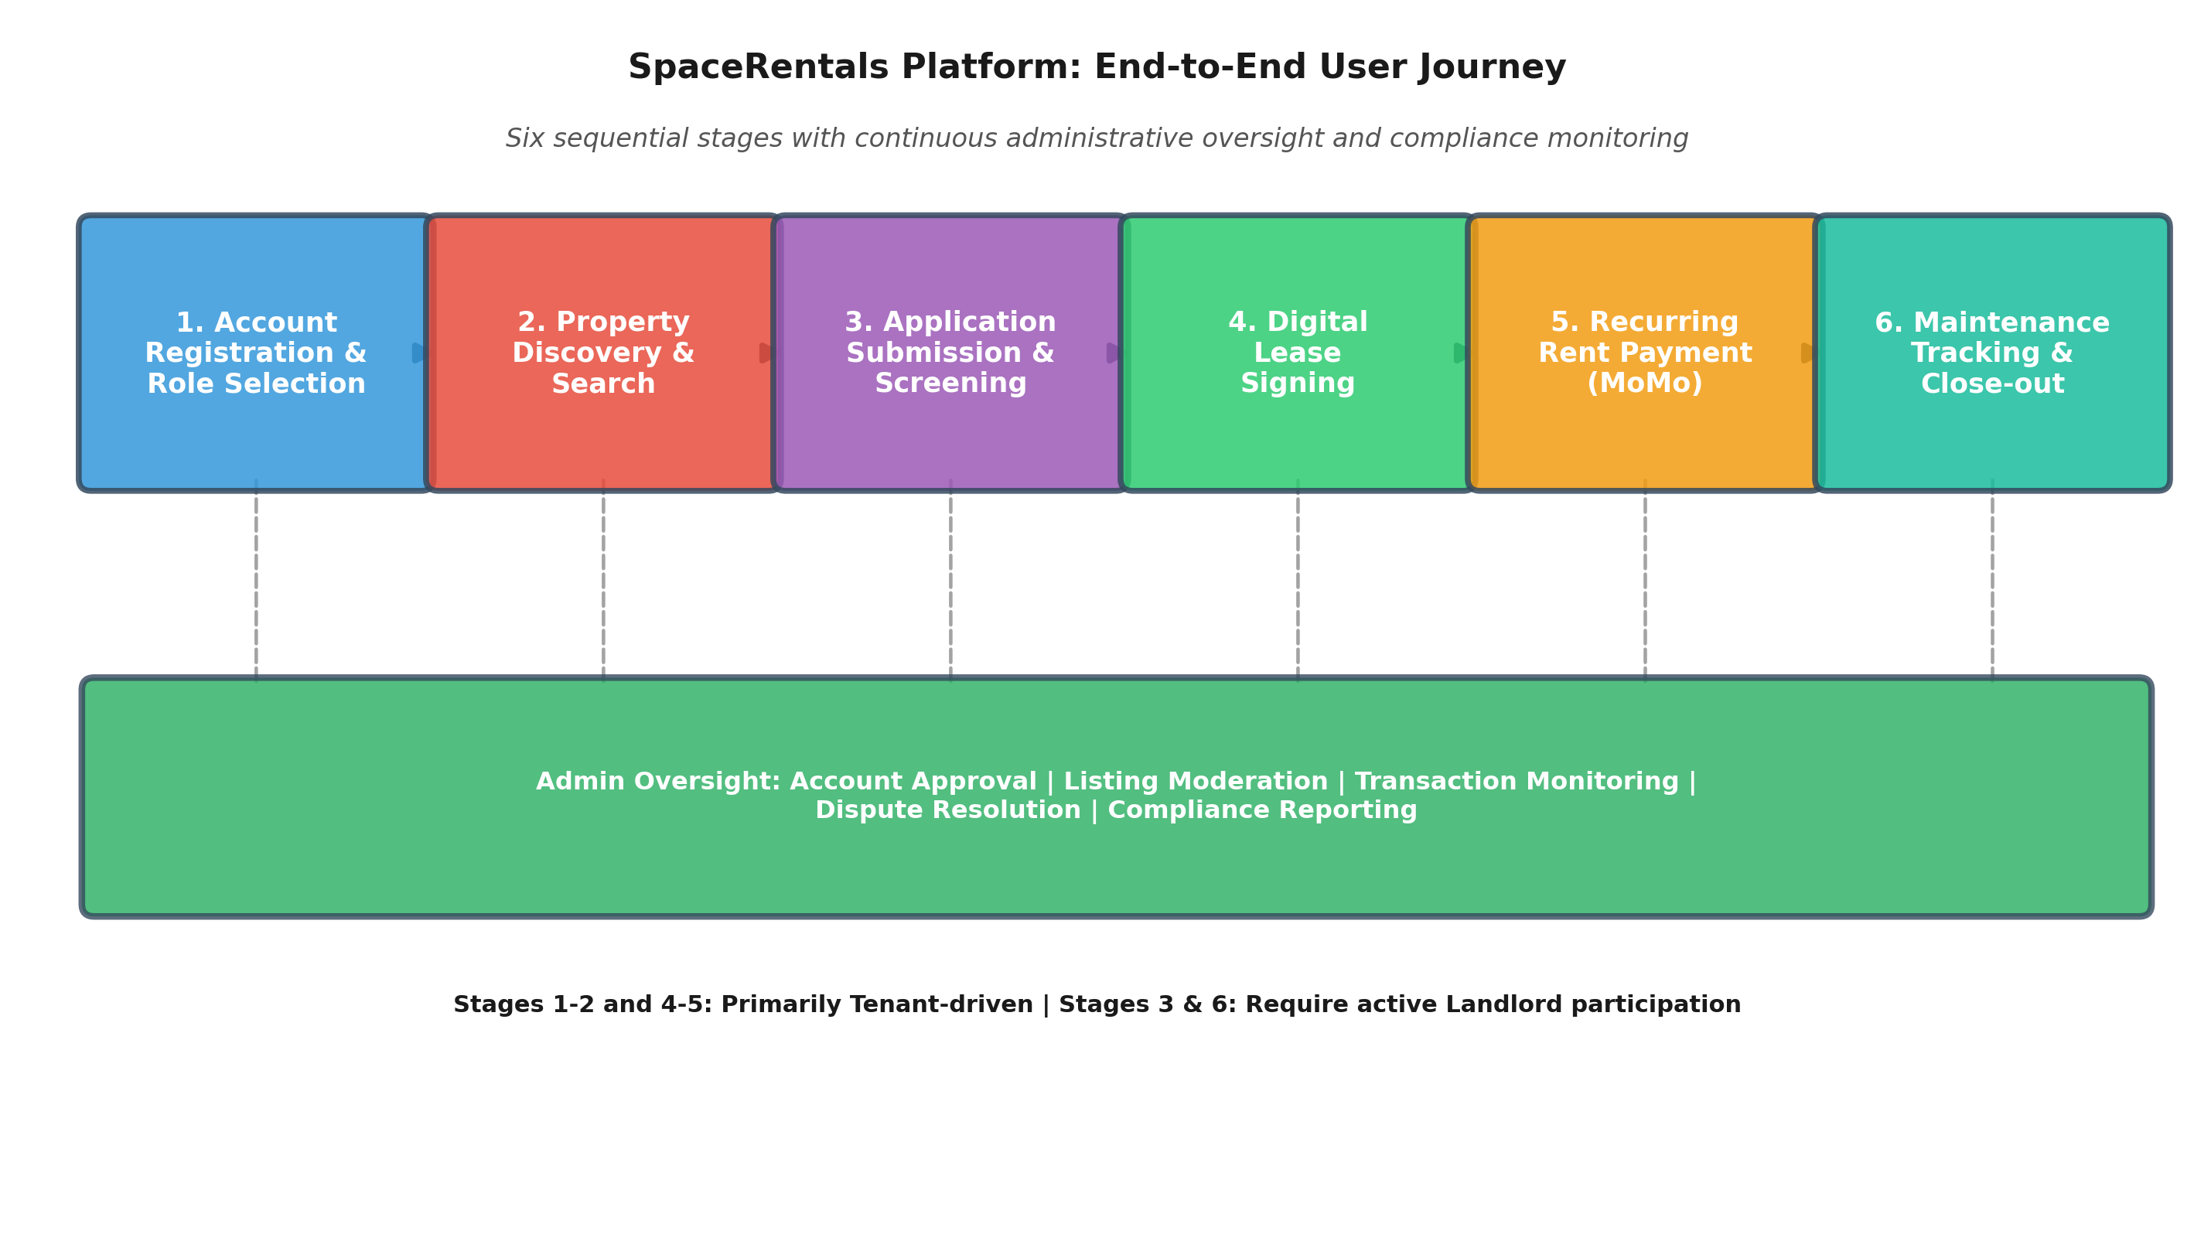
Figure 3.10: SpaceRentals Application Workflow with Admin Oversight
Two features of this workflow are worth highlighting for the defense. First, Admin oversight, account approval, listing moderation, transaction monitoring, dispute resolution, and compliance reporting, is depicted as running continuously beneath all six stages rather than as a final review step, which reflects how the Admin role was scoped in Chapter One, Section 1.3. Second, stages three, four, and six require active participation from both the Tenant and the Landlord, while stages one, two, and five are primarily Tenant-driven, a distinction that directly shaped the role-based dashboards specified in the use case diagram in Figure 3.4.

3.10 Tools and Technologies Used
Table 3.7 summarizes the technology stack selected for each architectural layer shown in Figure 3.9, together with the justification for each choice.
Layer | Technology | Justification
Frontend | React Native for cross-platform UI, CSS for styling and layout, React Router for in-app navigation and routing | A single component-based codebase that can target mobile and web, with familiar CSS-based styling and declarative, role-aware routing between Tenant, Landlord, and Admin screens
Backend | Supabase (Backend-as-a-Service): Edge Functions for business logic and an auto-generated PostgREST API | Removes the need to build and operate a custom server, letting development effort focus on rental-specific business logic rather than backend infrastructure
Data layer | Supabase-managed PostgreSQL database with Row-Level Security (RLS) policies | A fully managed relational database with policy-based access control enforced close to the data, so a Tenant, Landlord, or Admin can only read or write records their role permits
Storage & realtime | Supabase Storage for uploaded documents; Supabase Realtime for live updates | Handles identity documents and lease files submitted during screening, and pushes live status updates, such as a newly approved application, to the client without polling
Payments | MTN Mobile Money (MoMo) Open API, Orange Money Merchant API, called from Supabase Edge Functions | The two dominant mobile payment providers in Cameroon (Chapter Two, Section 2.5)
Auth & audit logging | Supabase Auth for role-based authentication; a timestamped, append-only audit_log table | Evidentiary support for disputes under Cameroon's electronic signature framework, discussed in Chapter Two
Table 3.7: Technology Stack Summary by Architectural Layer

3.11 System Testing Strategy
Testing follows a layered strategy intended to catch defects as early and cheaply as possible in the development cycle, summarized in Table 3.8.
Test Type | Tool | Scope / Example
Unit testing | Jest with React Native Testing Library | Rent calculation logic, lease-state transitions, and individual input-validation functions tested in isolation
Integration testing | Jest against a Supabase staging project | Confirms a rent payment recorded through MTN MoMo or Orange Money correctly updates a tenant's payment history and a landlord's income report, and that RLS policies enforce the correct role-based access
User acceptance testing | Manual, scripted scenarios | Each of the three role-based dashboards is walked through end-to-end scenarios, such as approving an application or signing and archiving a lease, against the objectives in Chapter One
Table 3.8: System Testing Strategy Summary

3.12 Ethical Considerations
Because SpaceRentals handles personally identifiable information, including identity documents submitted during tenant screening, financial data associated with rent payments, and digitally signed lease agreements, the project treats data protection as a core design constraint rather than an afterthought. All stakeholder consultations conducted during data collection were voluntary and anonymized in this report; no participant's identifying details are disclosed. Application documents, payment records, and signed leases are stored with role-based access control so that a given user can only view records relevant to their own tenancy, property, or administrative function, and audit logs are retained to support dispute resolution without exposing unrelated user data. These practices are intended to align the system's data handling with the spirit of Cameroon's Law on Cybersecurity and Cybercriminality, discussed in Chapter Two, even though the project itself operates as an academic proof-of-concept rather than a licensed financial or credit-reporting service.

3.13 Limitations of the Methodology
Two methodological limitations should be noted. First, because stakeholder consultation during data collection was informal and conducted with a small, convenience-based group of prospective tenants and landlords in Yaoundé rather than a statistically representative sample, the requirements it produced should be understood as directionally informative rather than exhaustively validated across Cameroon's full rental market. Second, the DSRM evaluation activity described in Section 3.2 is scoped to functional and usability testing of the developed artifact within the academic project timeline, and does not extend to a longitudinal field deployment measuring real-world adoption; the Technology Acceptance Model constructs introduced in Chapter Two therefore inform the system's design rather than being empirically measured against real user populations within the scope of this project.

REFERENCES
SimTrade Blog. (2025). About the Cameroonian Real Estate Market. https://www.simtrade.fr/blog_simtrade/cameroonian-real-estate-market/
The Africanvestor. (2026). 14 statistics for the Cameroon real estate market in 2025. https://theafricanvestor.com/blogs/news/cameroon-real-estate-market
The Africanvestor. (2026). Exact Rents in Cameroon (2026). https://theafricanvestor.com/blogs/news/cameroon-rents
Diamond Realty. (2021). Forecasting the Cameroonian Real Estate Sector. https://www.diamondrealty.estate/forecasting-the-cameroonian-real-estate-sector/
ResearchGate. (2015). Identification, analysis, evaluation and possible solutions of the problem of housing in Cameroon: Case study of Douala and Yaounde. https://www.researchgate.net/publication/283644360
Business in Cameroon. (2025). Cameroon emerges as key market for Orange Money in Africa. https://www.businessincameroon.com/finance/2805-14703-cameroon-emerges-as-key-market-for-orange-money-in-africa
Signable. (2024). Information on electronic Signature legality in Cameroon. https://www.signable.co.uk/electronic-signature-legality/africa/cameroon/
DocuSign. eSignature Legality in Cameroon. https://www.docusign.com/products/electronic-signature/legality/cameroon
Neneng Law Office. Electronic Commerce Law in Cameroon. https://www.nenenglawoffice.com/post/electronic-commerce-law
Precedence Research. (2026). PropTech Market Size Expected to Hit USD 185.31 Bn By 2035. https://www.precedenceresearch.com/proptech-market
Market Research Intellect. (2026). Global Rental Property Management Software Market Report 2035. https://www.marketresearchintellect.com/product/rental-property-management-software-market/
EBSCO Research Starters. Technology Acceptance Model (TAM). https://www.ebsco.com/research-starters/technology/technology-acceptance-model-tam
Davis, F. D. (1989). Perceived usefulness, perceived ease of use, and user acceptance of information technology. MIS Quarterly, 13(3), 319-340.
Stessa. AppFolio vs. Buildium: Which Tool Is Right for Your Portfolio? https://www.stessa.com/blog/appfolio-vs-buildium/
TenantCloud. AppFolio vs Buildium: Which Software is Best for Your Portfolio. https://www.tenantcloud.com/review/appfolio-vs-buildium
Afrirentals. Real Estate Listings in Cameroon. https://afrirentals.com/page/real-estate-listings-in-cameroon
Apple App Store. Ndabose - Homes for Sale and Rent. https://apps.apple.com/us/app/ndabose/id6448200031
Just Homes Blog. (2025). Best Real Estate App to Buy or Rent Property in Kenya. https://justhomes.co.ke/en/blog/best-real-estate-app-to-buy-or-rent-property-in-kenya/
Peffers, K., Tuunanen, T., Rothenberger, M. A., & Chatterjee, S. (2007). A Design Science Research Methodology for Information Systems Research. Journal of Management Information Systems, 24(3), 45-77.
Geerts, G. L. (2011). A design science research methodology and its application to accounting information systems research. International Journal of Accounting Information Systems, 12(2), 142-151.
Beck, K. et al. (2001). Manifesto for Agile Software Development. https://agilemanifesto.org/
Atlassian. Scrum Sprints. https://www.atlassian.com/agile/scrum/sprints
TechTarget. What is a sprint (software development)? https://www.techtarget.com/searchsoftwarequality/definition/Sprint-software-development
Object Management Group (OMG). About the Unified Modeling Language Specification Version 2.5.1. https://www.omg.org/spec/UML/2.5.1/About-UML
uml-diagrams.org. Unified Modeling Language (UML) reference and diagram guide. https://www.uml-diagrams.org/
GeeksforGeeks. Unified Modeling Language (UML) Diagrams. https://www.geeksforgeeks.org/system-design/unified-modeling-language-uml-introduction/

